# Distributed Machine deployment:

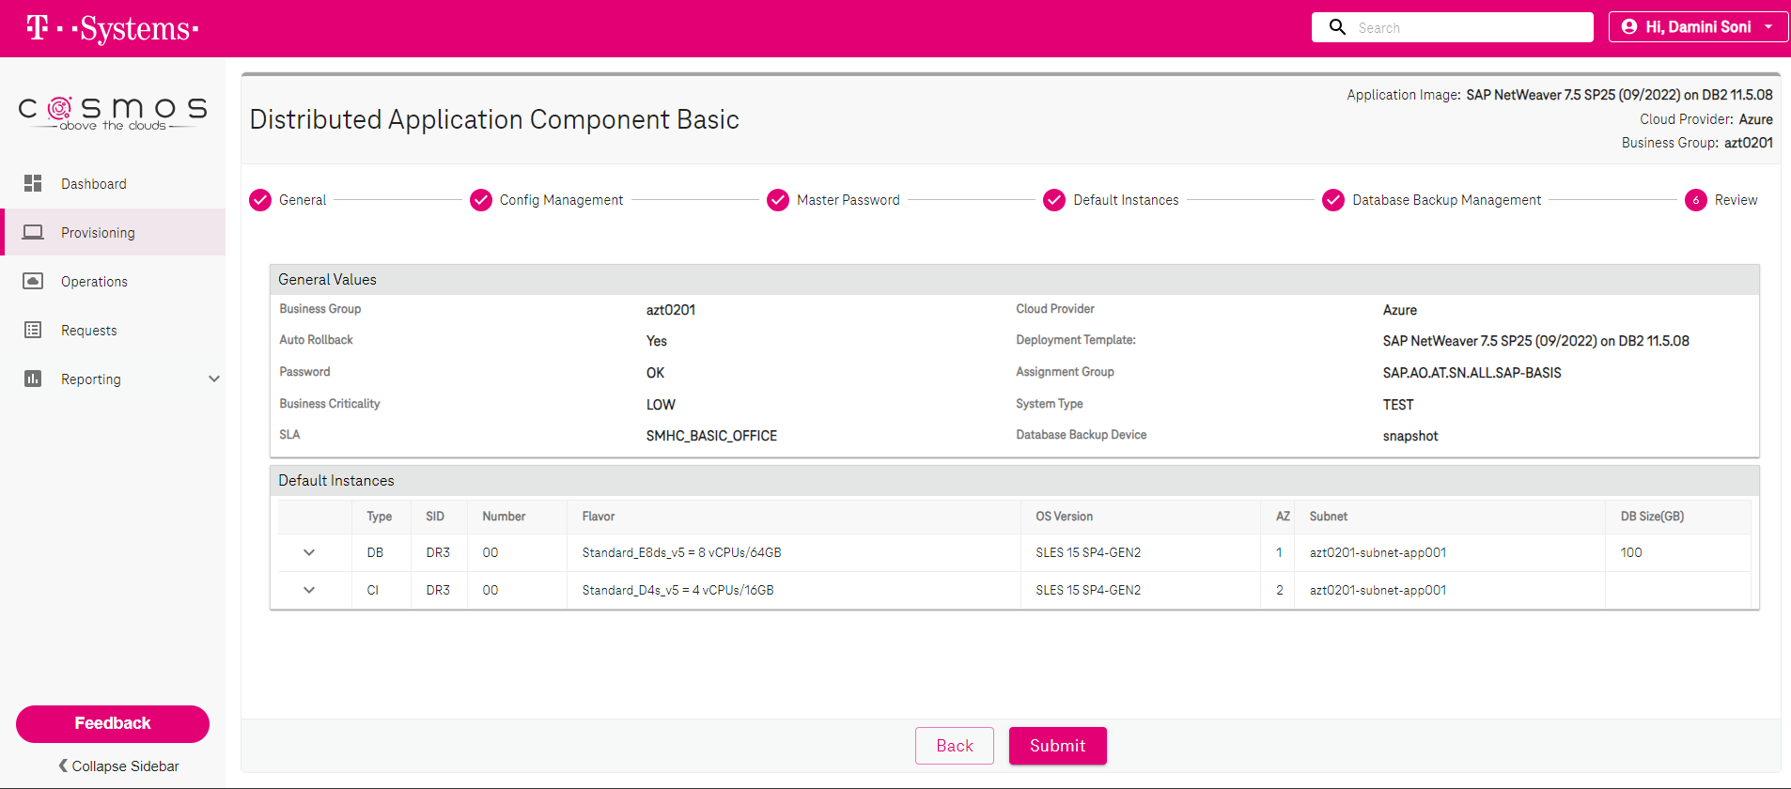

aztdbdr30001:db2dr3 7> db2 backup db dr3

Backup successful. The timestamp for this backup image is : 20230814120120



**NOTE: Make sure cron for xbrarchive is disabled till hadr is completely setup on both machines.**

# Add standby database machine:

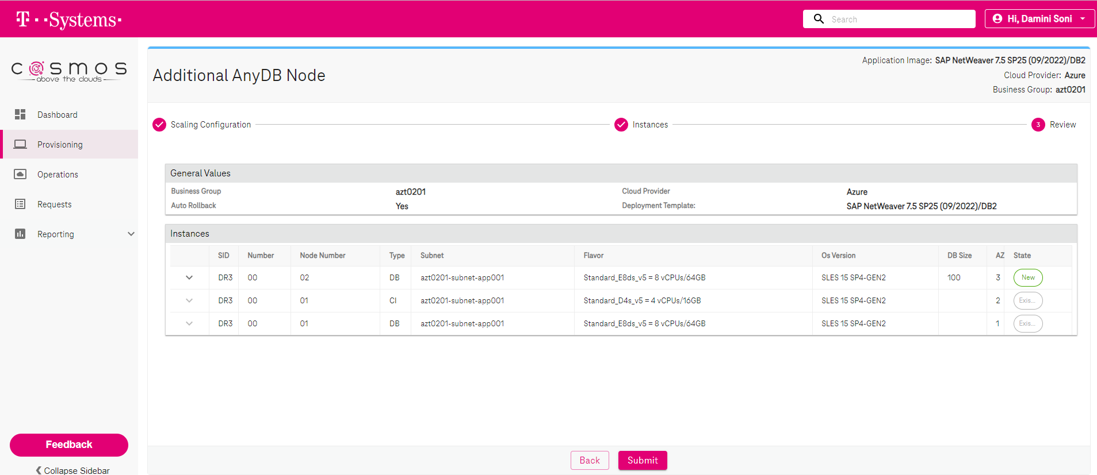

aztcidr30001.azt0201.azure.local

aztdbdr30001.azt0201.azure.local

aztdbdr30002.azt0201.azure.local

**On standby machine (**aztdbdr30002.azt0201.azure.local**):**

To set up the Standby database server by using the SAP homogeneous system copy procedure, execute these steps:

1. Select the **System copy** option > **Target systems** > **Distributed** > **Database instance**.
2. As a copy method, select **Homogeneous System** so that you can use backup to restore a backup on the standby server instance.
3. When you reach the exit step to restore the database for homogeneous system copy, exit the installer. Restore the database from a backup of the primary host. All subsequent installation phases have already been executed on the primary database server.
4. Set up HADR for IBM Db2.

aztdbdr30002:~ # cd /tmp

aztdbdr30002:/tmp # mkdir sapinst_instdir

aztdbdr30002:/tmp # chmod 777 sapinst_instdir

aztdbdr30002:/tmp # cd sapinst_instdir

aztdbdr30002:/tmp/sapinst_instdir # mkdir SWPM

aztdbdr30002:/tmp/sapinst_instdir # chmod 777 SWPM

aztdbdr30002:/tmp/sapinst_instdir # mkdir DB

aztdbdr30002:/tmp/sapinst_instdir # chmod 777 DB

aztdbdr30002:/tmp/sapinst_instdir # cp -pR /sharedstorage/klbrand/SW/NW75SP25-DB2/SWPM10SP36_3-20009701.SAR /tmp/sapinst_instdir/SWPM

aztdbdr30002:/tmp/sapinst_instdir # cd /tmp/sapinst_instdir/SWPM

aztdbdr30002:/tmp/sapinst_instdir/SWPM # /sharedstorage/klbrand/SW/SAPCAR_1115-70006178.EXE -xvf SWPM10SP36_3-20009701.SAR

aztdbdr30002:/tmp/sapinst_instdir/SWPM # cd ../DB

aztdbdr30002:/tmp/sapinst_instdir/DB # /tmp/sapinst_instdir/SWPM/sapinst SAPINST_REMOTE_ACCESS_USER=dr3adm

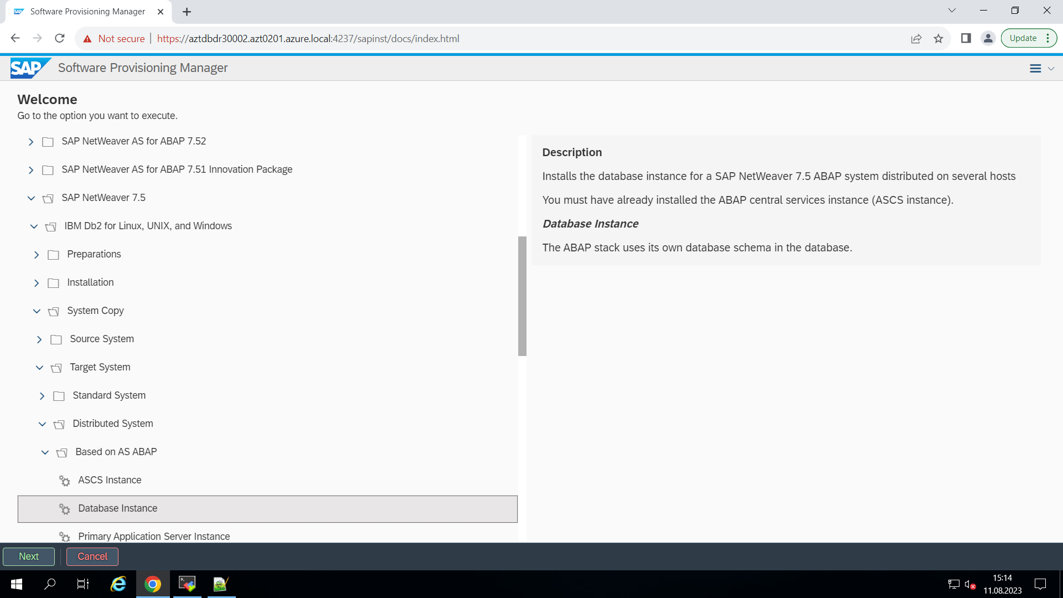

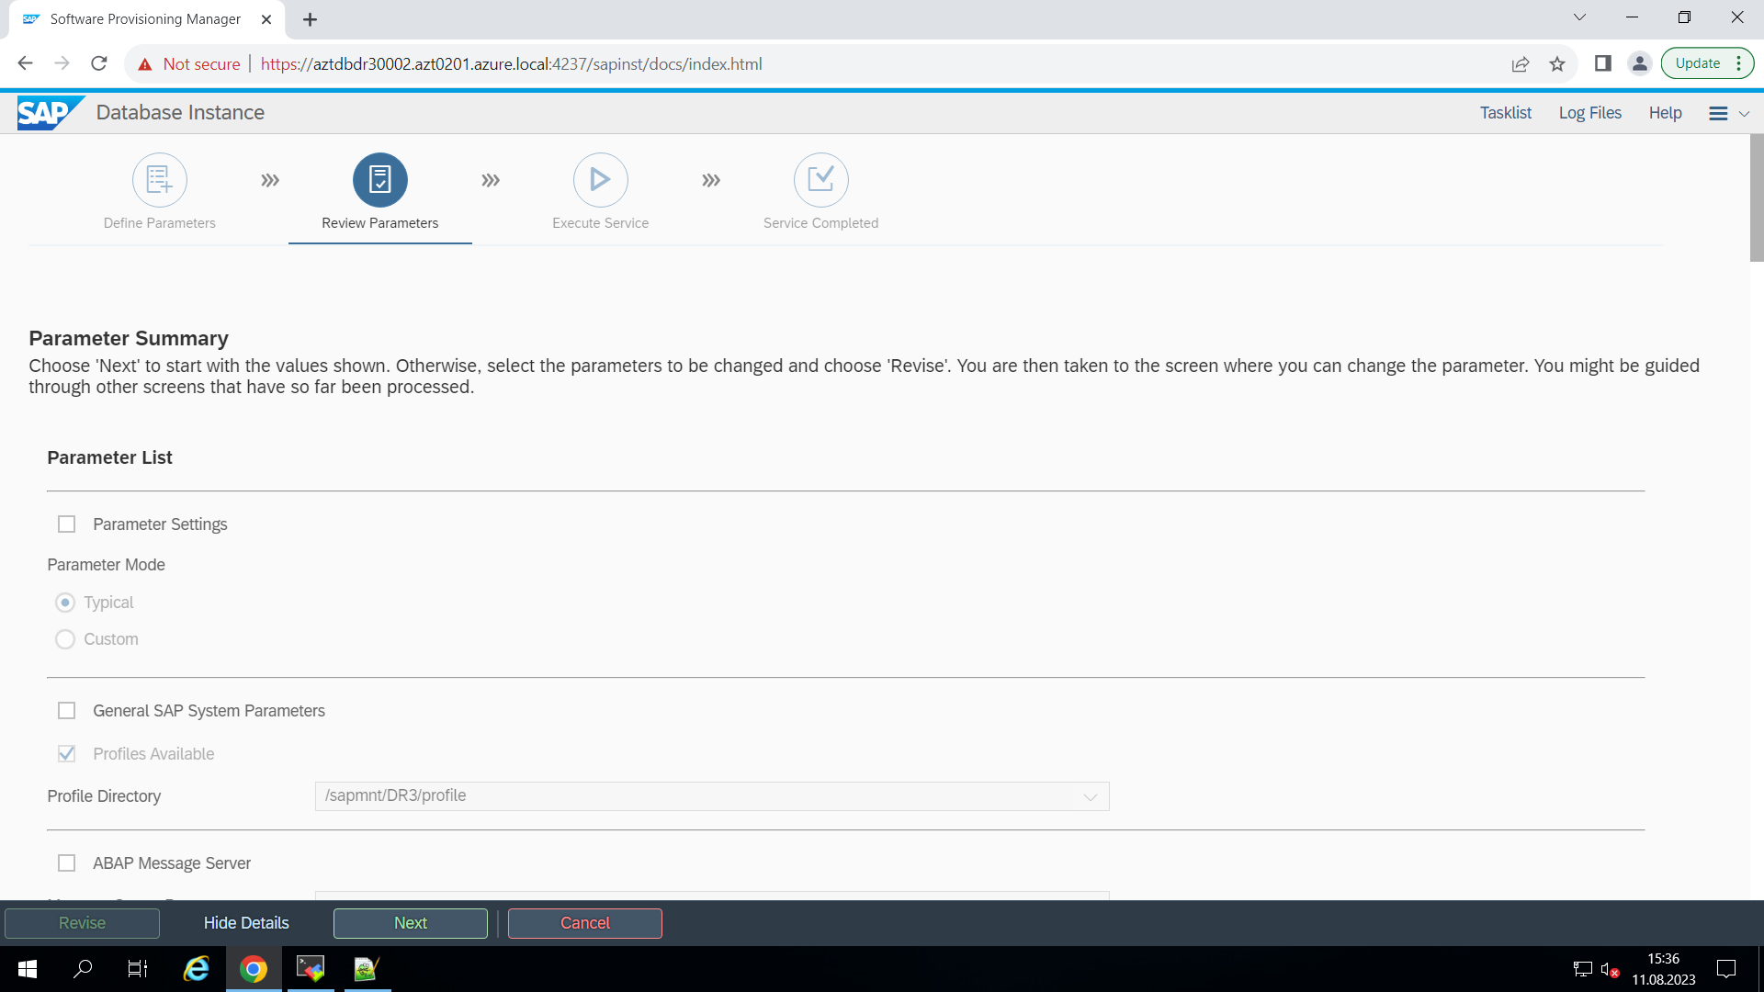

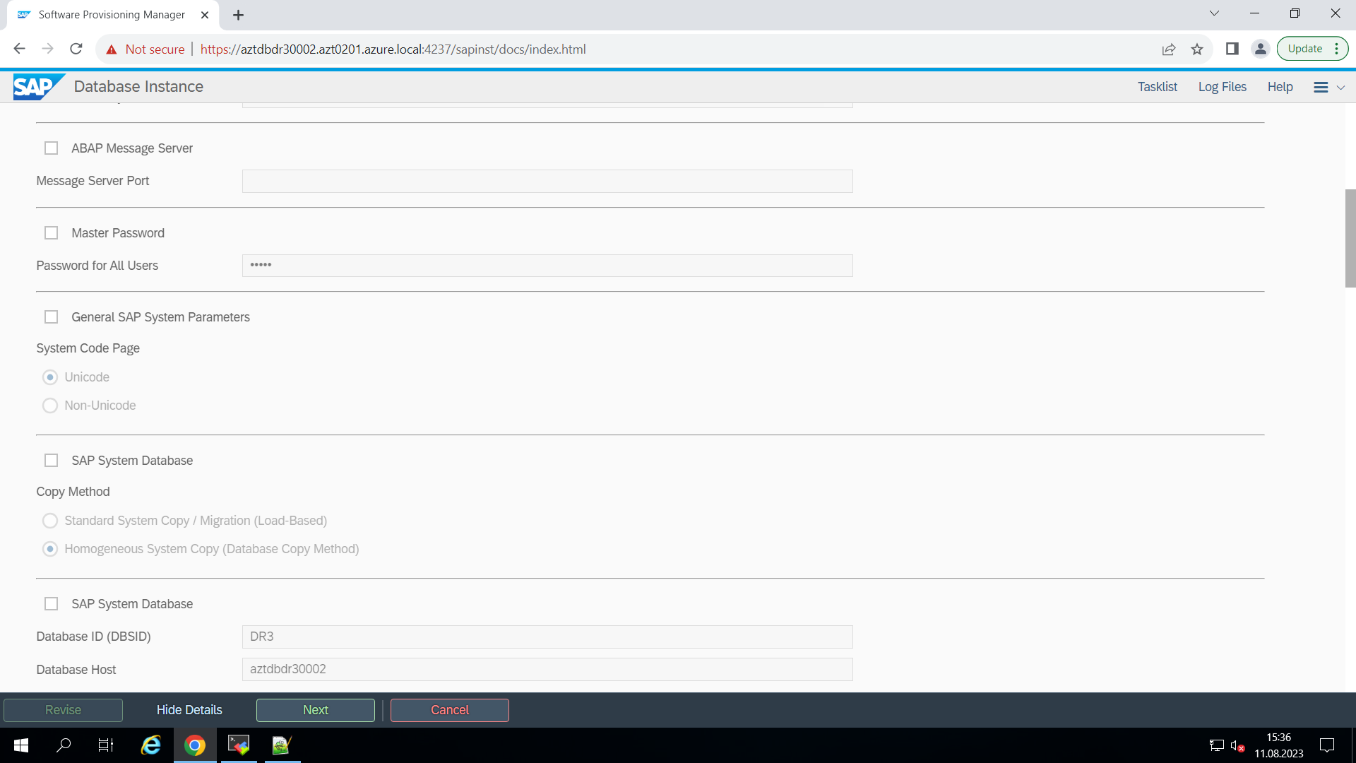

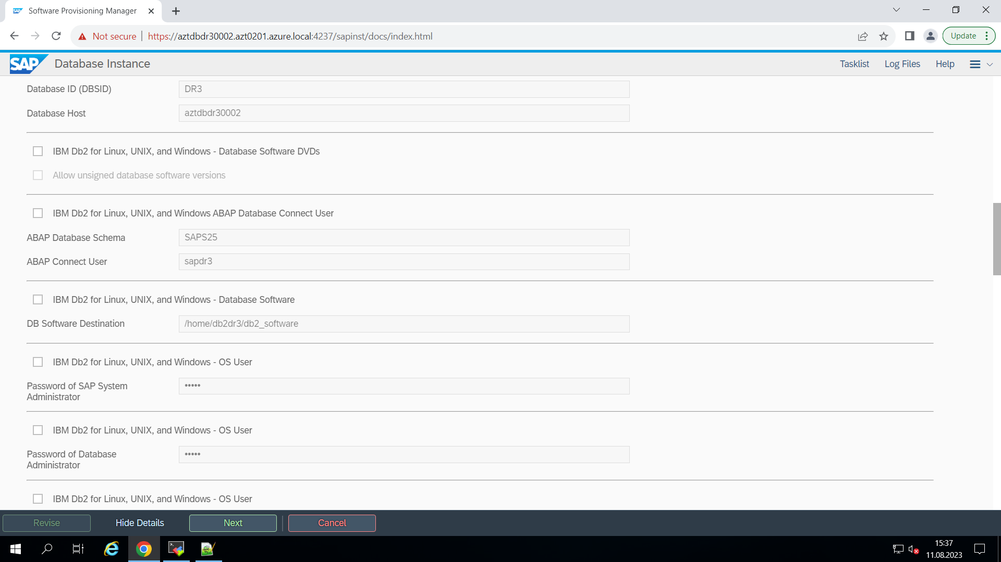

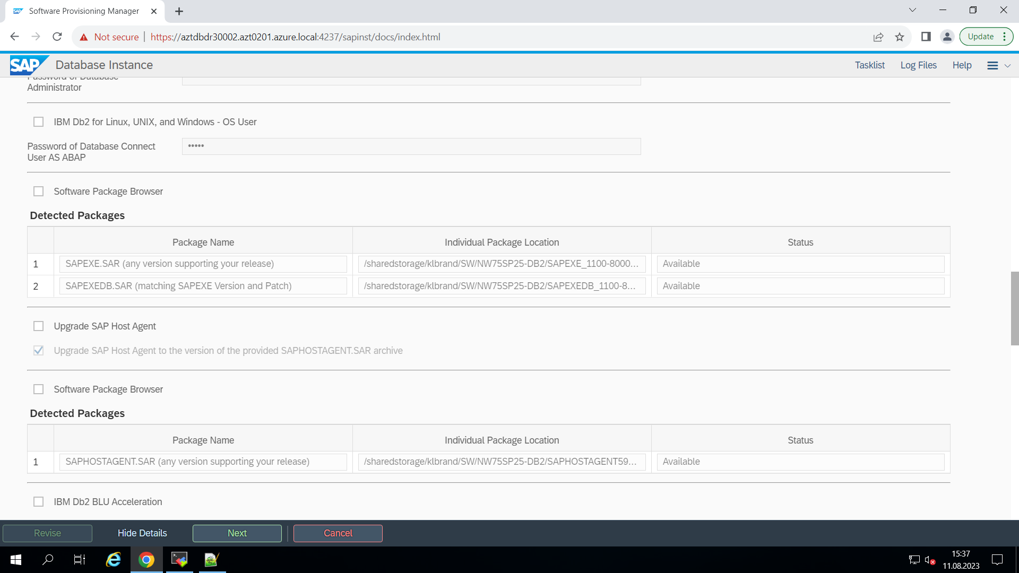

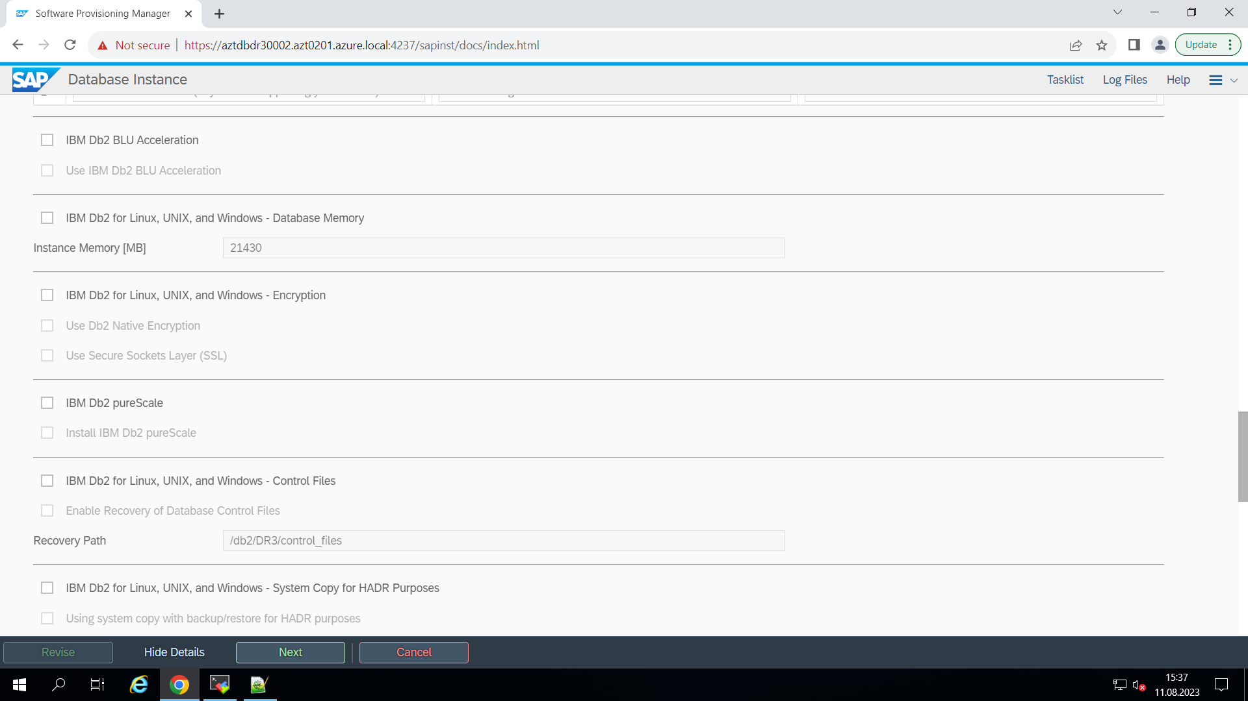

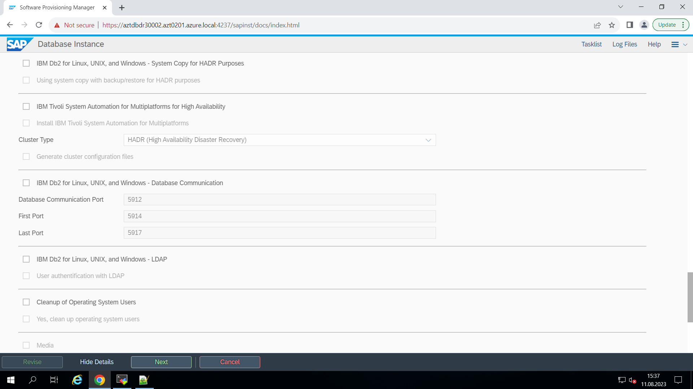

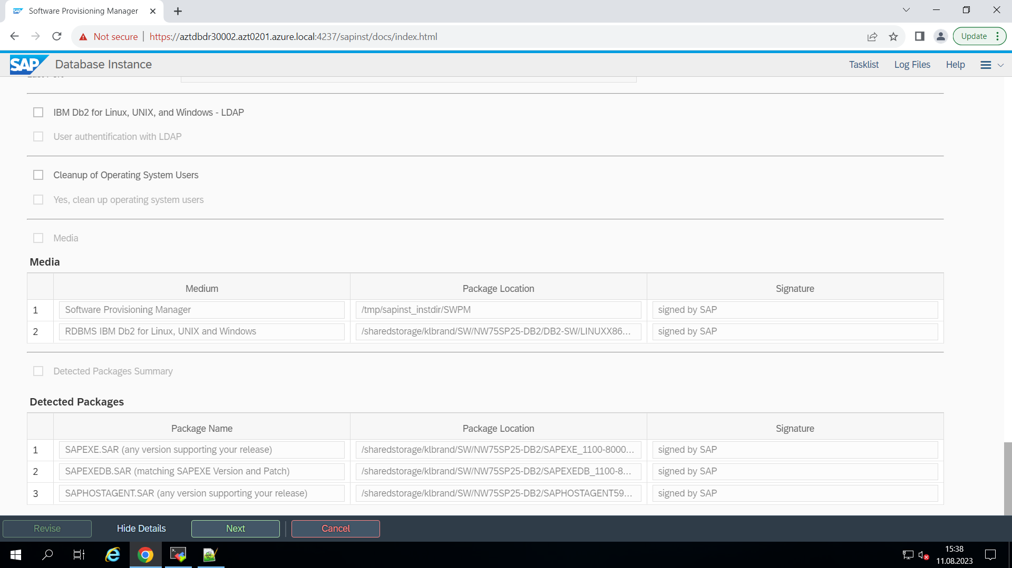

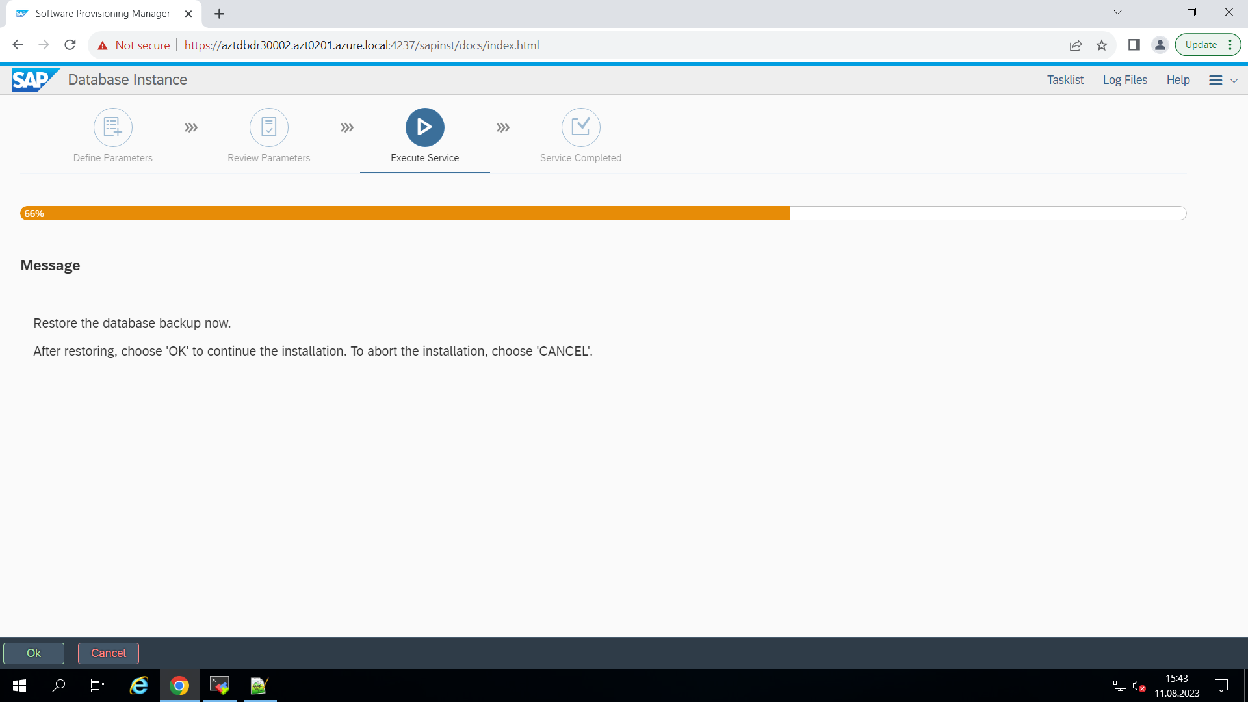

# HADR PREREQUISITES SETUP

aztdbdr30001:~ # cat /etc/hosts | grep azt0201

192.168.20.248 aztdbdr30002.azt0201.azure.local aztdbdr30002

192.168.20.70 aztdbdr30001.azt0201.azure.local aztdbdr30001

aztdbdr30002:~ # cat /etc/hosts | grep azt0201

192.168.20.248 aztdbdr30002.azt0201.azure.local aztdbdr30002

192.168.20.70 aztdbdr30001.azt0201.azure.local aztdbdr30001

aztdbdr30001:~ # cat /etc/services | grep hadr

db2_hadr_1 50001/tcp

db2_hadr_2 50002/tcp

aztdbdr30002:~ # cat /etc/services | grep hadr

db2_hadr_1 50001/tcp

db2_hadr_2 50002/tcp

**Note: Makes sure database svc port is open (check /etc/services and remove # if in place of svc port)**

# HADR Configuration:

Primary DB HADR configuration  
  
db2 UPDATE DB CFG FOR DR3 USING HADR_LOCAL_HOST aztdbdr30001.azt0201.azure.local

db2 UPDATE DB CFG FOR DR3 USING HADR_LOCAL_SVC 50001

db2 UPDATE DB CFG FOR DR3 USING HADR_REMOTE_HOST aztdbdr30002.azt0201.azure.local

db2 UPDATE DB CFG FOR DR3 USING HADR_REMOTE_SVC 50002

db2 UPDATE DB CFG FOR DR3 USING HADR_REMOTE_INST db2dr3

db2 UPDATE DB CFG FOR DR3 USING HADR_TIMEOUT 120

db2 UPDATE DB CFG FOR DR3 USING HADR_SYNCMODE NEARSYNC

db2 UPDATE DB CFG FOR DR3 USING HADR_SPOOL_LIMIT 1000

db2 UPDATE DB CFG FOR DR3 USING HADR_PEER_WINDOW 240

db2 UPDATE DB CFG FOR DR3 USING indexrec RESTART logindexbuild ON

**Backup Primary database:**

aztdbdr30001:db2dr3 26> db2 backup db dr3 online compress include logs

Backup successful. The timestamp for this backup image is : 20230814121424

aztdbdr30001:db2dr3 50> chmod 777 DR3.0.db2dr3.DBPART000.20230811141002.001

aztdbdr30001:db2dr3 51> cp DR3.0.db2dr3.DBPART000.20230811141002.001 /tmp

**Copy the online backup of primary database into new db host and restore the database**

16:16:50 a200246669@sec0564:~$ xscp linux@aztdbdr30001.azt0201.azure.local:/tmp/DR3.0.db2dr3.DBPART000.20230811141002.001 [linux@aztdbdr30002.azt0201.azure.local:/tmp/](mailto:linux@aztdbdr30002.azt0201.azure.local:/tmp/)

Warning: Permanently added 'aztdbdr30002.azt0201.azure.local' (ECDSA) to the list of known hosts.

Warning: Permanently added 'aztdbdr30001.azt0201.azure.local' (ECDSA) to the list of known hosts.

###############################################################################

# Transfer finished #

###############################################################################

aztdbdr30002:db2dr3 5> db2 restore db dr3 from /tmp taken at 20230811141002

DB20000I The RESTORE DATABASE command completed successfully.

aztdbdr30002:db2dr3 6> db2 list db directory

System Database Directory

Number of entries in the directory = 1

Database 1 entry:

Database alias = DR3

Database name = DR3

Local database directory = /db2/DR3

Database release level = 15.00

Comment = SAP database S25

Directory entry type = Indirect

Catalog database partition number = 0

Alternate server hostname =

Alternate server port number =

**Note: Standby database should be in rollforward pending status**

aztdbdr30002:db2dr3 7> db2 rollforward db dr3 query status

Rollforward Status

Input database alias = dr3

Number of members have returned status = 1

Member ID = 0

Rollforward status = DB pending

Next log file to be read = S0000011.LOG

Log files processed = -

Last committed transaction = 2023-08-11-14.13.35.000000 UTC

In new crated database (Standby):

db2 UPDATE DB CFG FOR DR3 USING HADR_LOCAL_HOST aztdbdr30002.azt0201.azure.local

db2 UPDATE DB CFG FOR DR3 USING HADR_LOCAL_SVC 50002

db2 UPDATE DB CFG FOR DR3 USING HADR_REMOTE_HOST aztdbdr30001.azt0201.azure.local

db2 UPDATE DB CFG FOR DR3 USING HADR_REMOTE_SVC 50001

aztdbdr30001:db2dr3 52> db2 get db cfg for dr3 | grep -i hadr

HADR database role = STANDARD

HADR local host name (HADR_LOCAL_HOST) = aztdbdr30001.azt0201.azure.local

HADR local service name (HADR_LOCAL_SVC) = 50001

HADR remote host name (HADR_REMOTE_HOST) = aztdbdr30002.azt0201.azure.local

HADR remote service name (HADR_REMOTE_SVC) = 50002

HADR instance name of remote server (HADR_REMOTE_INST) = db2dr3

HADR timeout value (HADR_TIMEOUT) = 120

HADR target list (HADR_TARGET_LIST) =

HADR log write synchronization mode (HADR_SYNCMODE) = NEARSYNC

HADR spool log data limit (4KB) (HADR_SPOOL_LIMIT) = 1000

HADR log replay delay (seconds) (HADR_REPLAY_DELAY) = 0

HADR peer window duration (seconds) (HADR_PEER_WINDOW) = 240

HADR SSL certificate label (HADR_SSL_LABEL) =

HADR SSL Hostname Validation (HADR_SSL_HOST_VAL) = OFF

aztdbdr30002:db2dr3 13> db2 get db cfg for dr3 | grep -i hadr

HADR database role = STANDARD

HADR local host name (HADR_LOCAL_HOST) = aztdbdr30002.azt0201.azure.local

HADR local service name (HADR_LOCAL_SVC) = 50002

HADR remote host name (HADR_REMOTE_HOST) = aztdbdr30001.azt0201.azure.local

HADR remote service name (HADR_REMOTE_SVC) = 50001

HADR instance name of remote server (HADR_REMOTE_INST) = db2dr3

HADR timeout value (HADR_TIMEOUT) = 120

HADR target list (HADR_TARGET_LIST) =

HADR log write synchronization mode (HADR_SYNCMODE) = NEARSYNC

HADR spool log data limit (4KB) (HADR_SPOOL_LIMIT) = 1000

HADR log replay delay (seconds) (HADR_REPLAY_DELAY) = 0

HADR peer window duration (seconds) (HADR_PEER_WINDOW) = 240

HADR SSL certificate label (HADR_SSL_LABEL) =

HADR SSL Hostname Validation (HADR_SSL_HOST_VAL) = OFF

**Start HADR:**

aztdbdr30002:db2dr3 14> db2 start hadr on db dr3 as standby

DB20000I The START HADR ON DATABASE command completed successfully.

aztdbdr30001:db2dr3 53> db2 activate db dr3

DB20000I The ACTIVATE DATABASE command completed successfully.

aztdbdr30001:db2dr3 54> db2 start hadr on db dr3 as primary

DB20000I The START HADR ON DATABASE command completed successfully.

**HADR Checks:**

aztdbdr30001:db2dr3 55> db2pd -d dr3 -hadr

Database Member 0 -- Database DR3 -- Active -- Up 0 days 00:01:31 -- Date 2023-08-11-14.45.28.350039

HADR_ROLE = PRIMARY

REPLAY_TYPE = PHYSICAL

HADR_SYNCMODE = NEARSYNC

STANDBY_ID = 1

LOG_STREAM_ID = 0

HADR_STATE = REMOTE_CATCHUP_PENDING

HADR_FLAGS = STANDBY_LOG_RETRIEVAL TCP_PROTOCOL

PRIMARY_MEMBER_HOST = aztdbdr30001.azt0201.azure.local

PRIMARY_INSTANCE = db2dr3

PRIMARY_MEMBER = 0

STANDBY_MEMBER_HOST = aztdbdr30002.azt0201.azure.local

STANDBY_INSTANCE = db2dr3

STANDBY_MEMBER = 0

HADR_CONNECT_STATUS = CONNECTED

HADR_CONNECT_STATUS_TIME = 08/11/2023 14:45:27.815609 (1691765127)

HEARTBEAT_INTERVAL(seconds) = 5

HEARTBEAT_MISSED = 0

HEARTBEAT_EXPECTED = 0

HADR_TIMEOUT(seconds) = 120

TIME_SINCE_LAST_RECV(seconds) = 1

PEER_WAIT_LIMIT(seconds) = 0

LOG_HADR_WAIT_CUR(seconds) = 0.000

LOG_HADR_WAIT_RECENT_AVG(seconds) = 0.000000

LOG_HADR_WAIT_ACCUMULATED(seconds) = 0.000

LOG_HADR_WAIT_COUNT = 0

SOCK_SEND_BUF_REQUESTED,ACTUAL(bytes) = 0, 87040

SOCK_RECV_BUF_REQUESTED,ACTUAL(bytes) = 0, 131072

PRIMARY_LOG_FILE,PAGE,POS = S0000015.LOG, 0, 38848356001

STANDBY_LOG_FILE,PAGE,POS = S0000011.LOG, 0, 38522276001

HADR_LOG_GAP(bytes) = 0

STANDBY_REPLAY_LOG_FILE,PAGE,POS = S0000011.LOG, 0, 38522276001

STANDBY_RECV_REPLAY_GAP(bytes) = 0

PRIMARY_LOG_TIME = 08/11/2023 14:35:23.000000 (1691764523)

STANDBY_LOG_TIME = 08/11/2023 14:05:22.000000 (1691762722)

STANDBY_REPLAY_LOG_TIME = 08/11/2023 14:05:22.000000 (1691762722)

STANDBY_RECV_BUF_SIZE(pages) = 2048

STANDBY_RECV_BUF_PERCENT = 0

STANDBY_SPOOL_LIMIT(pages) = 1000

STANDBY_SPOOL_PERCENT = 0

STANDBY_ERROR_TIME = NULL

PEER_WINDOW(seconds) = 240

READS_ON_STANDBY_ENABLED = N

HADR_LAST_TAKEOVER_TIME = NULL

aztdbdr30001:db2dr3 56>

aztdbdr30002:db2dr3 17> db2pd -d dr3 -hadr

Database Member 0 -- Database DR3 -- Standby -- Up 0 days 00:04:02 -- Date 2023-08-11-14.47.40.129299

HADR_ROLE = STANDBY

REPLAY_TYPE = PHYSICAL

HADR_SYNCMODE = NEARSYNC

STANDBY_ID = 0

LOG_STREAM_ID = 0

HADR_STATE = REMOTE_CATCHUP

HADR_FLAGS = TCP_PROTOCOL

PRIMARY_MEMBER_HOST = aztdbdr30001.azt0201.azure.local

PRIMARY_INSTANCE = db2dr3

PRIMARY_MEMBER = 0

STANDBY_MEMBER_HOST = aztdbdr30002.azt0201.azure.local

STANDBY_INSTANCE = db2dr3

STANDBY_MEMBER = 0

HADR_CONNECT_STATUS = CONNECTED

HADR_CONNECT_STATUS_TIME = 08/11/2023 14:47:38.916060 (1691765258)

HEARTBEAT_INTERVAL(seconds) = 5

HEARTBEAT_MISSED = 0

HEARTBEAT_EXPECTED = 0

HADR_TIMEOUT(seconds) = 120

TIME_SINCE_LAST_RECV(seconds) = 0

PEER_WAIT_LIMIT(seconds) = 0

LOG_HADR_WAIT_CUR(seconds) = 0.000

LOG_HADR_WAIT_RECENT_AVG(seconds) = 0.000000

LOG_HADR_WAIT_ACCUMULATED(seconds) = 0.000

LOG_HADR_WAIT_COUNT = 0

SOCK_SEND_BUF_REQUESTED,ACTUAL(bytes) = 0, 87040

SOCK_RECV_BUF_REQUESTED,ACTUAL(bytes) = 0, 131072

PRIMARY_LOG_FILE,PAGE,POS = S0000015.LOG, 0, 38848356001

STANDBY_LOG_FILE,PAGE,POS = S0000011.LOG, 0, 38522276001

HADR_LOG_GAP(bytes) = 0

STANDBY_REPLAY_LOG_FILE,PAGE,POS = S0000011.LOG, 0, 38522276001

STANDBY_RECV_REPLAY_GAP(bytes) = 0

PRIMARY_LOG_TIME = 08/11/2023 14:35:23.000000 (1691764523)

STANDBY_LOG_TIME = 08/11/2023 14:05:22.000000 (1691762722)

STANDBY_REPLAY_LOG_TIME = 08/11/2023 14:05:22.000000 (1691762722)

STANDBY_RECV_BUF_SIZE(pages) = 2048

STANDBY_RECV_BUF_PERCENT = 0

STANDBY_SPOOL_LIMIT(pages) = 1000

STANDBY_SPOOL_PERCENT = 0

STANDBY_ERROR_TIME = NULL

PEER_WINDOW(seconds) = 240

READS_ON_STANDBY_ENABLED = N

HADR_LAST_TAKEOVER_TIME = NULL

aztdbdr30002:db2dr3 18>

aztdbdr30001:db2dr3 57> nmap -p 50001 aztdbdr30001

Starting Nmap 7.92 ( https://nmap.org ) at 2023-08-11 14:48 UTC

Nmap scan report for aztdbdr30001 (192.168.20.70)

Host is up (0.000080s latency).

rDNS record for 192.168.20.70: aztdbdr30001.azt0201.azure.local

PORT STATE SERVICE

50001/tcp open unknown

Nmap done: 1 IP address (1 host up) scanned in 0.05 seconds

aztdbdr30001:db2dr3 58>

aztdbdr30002:db2dr3 18> nmap -p 50002 aztdbdr30002

Starting Nmap 7.92 ( https://nmap.org ) at 2023-08-11 14:48 UTC

Nmap scan report for aztdbdr30002 (192.168.20.248)

Host is up (0.000061s latency).

rDNS record for 192.168.20.248: aztdbdr30002.azt0201.azure.local

PORT STATE SERVICE

50002/tcp open iiimsf

Nmap done: 1 IP address (1 host up) scanned in 0.05 seconds

aztdbdr30002:db2dr3 19>

aztcidr30001:dr3adm 9> startsap

Checking db Database

Database is running

-------------------------------------------

Starting Startup Agent sapstartsrv

OK

Instance Service on host aztcidr30001 started

-------------------------------------------

starting SAP Instance ASCS01

Startup-Log is written to /usr/sap/DR3/home/startsap_ASCS01.log

-------------------------------------------

/usr/sap/DR3/ASCS01/exe/sapcontrol -prot NI_HTTP -nr 01 -function Start

Instance on host aztcidr30001 started

Starting Startup Agent sapstartsrv

OK

Instance Service on host aztcidr30001 started

-------------------------------------------

starting SAP Instance D00

Startup-Log is written to /usr/sap/DR3/home/startsap_D00.log

-------------------------------------------

/usr/sap/DR3/D00/exe/sapcontrol -prot NI_HTTP -nr 00 -function Start

Instance on host aztcidr30001 started

aztcidr30001:dr3adm 10>

aztdbdr30001:db2dr3 58> db2 list active databases

Active Databases

Database name = DR3

Applications connected currently = 20

Database path = /db2/DR3/db2dr3/NODE0000/SQL00001/MEMBER0000/

aztdbdr30001:db2dr3 59> db2stop force

08/11/2023 14:53:28 0 0 SQL1064N DB2STOP processing was successful.

SQL1064N DB2STOP processing was successful.

aztdbdr30002:db2dr3 34> db2pd -d dr3 -hadr

Database Member 0 -- Database DR3 -- Standby -- Up 0 days 00:02:05 -- Date 2023-08-11-15.26.14.945171

HADR_ROLE = STANDBY

REPLAY_TYPE = PHYSICAL

HADR_SYNCMODE = NEARSYNC

STANDBY_ID = 0

LOG_STREAM_ID = 0

HADR_STATE = DISCONNECTED_PEER

HADR_FLAGS =

PRIMARY_MEMBER_HOST = aztdbdr30001.azt0201.azure.local

PRIMARY_INSTANCE = db2dr3

PRIMARY_MEMBER = 0

STANDBY_MEMBER_HOST = aztdbdr30002.azt0201.azure.local

STANDBY_INSTANCE = db2dr3

STANDBY_MEMBER = 0

HADR_CONNECT_STATUS = DISCONNECTED

HADR_CONNECT_STATUS_TIME = 08/11/2023 15:26:05.533511 (1691767565)

HEARTBEAT_INTERVAL(seconds) = 5

HEARTBEAT_MISSED = 0

HEARTBEAT_EXPECTED = 17

HADR_TIMEOUT(seconds) = 120

TIME_SINCE_LAST_RECV(seconds) = 0

PEER_WAIT_LIMIT(seconds) = 0

LOG_HADR_WAIT_CUR(seconds) = 0.000

LOG_HADR_WAIT_RECENT_AVG(seconds) = 0.000427

LOG_HADR_WAIT_ACCUMULATED(seconds) = 0.001

LOG_HADR_WAIT_COUNT = 3

SOCK_SEND_BUF_REQUESTED,ACTUAL(bytes) = 0, 16384

SOCK_RECV_BUF_REQUESTED,ACTUAL(bytes) = 0, 131072

PRIMARY_LOG_FILE,PAGE,POS = S0000017.LOG, 0, 39011396001

STANDBY_LOG_FILE,PAGE,POS = S0000017.LOG, 0, 39011396001

HADR_LOG_GAP(bytes) = 0

STANDBY_REPLAY_LOG_FILE,PAGE,POS = S0000017.LOG, 0, 39011396001

STANDBY_RECV_REPLAY_GAP(bytes) = 0

PRIMARY_LOG_TIME = 08/11/2023 15:25:37.000000 (1691767537)

STANDBY_LOG_TIME = 08/11/2023 15:25:37.000000 (1691767537)

STANDBY_REPLAY_LOG_TIME = 08/11/2023 15:25:37.000000 (1691767537)

STANDBY_RECV_BUF_SIZE(pages) = 2048

STANDBY_RECV_BUF_PERCENT = 0

STANDBY_SPOOL_LIMIT(pages) = 1000

STANDBY_SPOOL_PERCENT = 0

STANDBY_ERROR_TIME = NULL

PEER_WINDOW(seconds) = 240

PEER_WINDOW_END = 08/11/2023 15:30:02.000000 (1691767802)

READS_ON_STANDBY_ENABLED = N

HADR_LAST_TAKEOVER_TIME = NULL

aztdbdr30002:db2dr3 35>

aztdbdr30002:db2dr3 35> db2 takeover hadr on database DR3 by force

DB20000I The TAKEOVER HADR ON DATABASE command completed successfully.

aztdbdr30002:db2dr3 36> db2pd -d dr3 -hadr

Database Member 0 -- Database DR3 -- Active -- Up 0 days 00:06:02 -- Date 2023-08-11-15.30.11.501223

HADR_ROLE = PRIMARY

REPLAY_TYPE = PHYSICAL

HADR_SYNCMODE = NEARSYNC

STANDBY_ID = 1

LOG_STREAM_ID = 0

HADR_STATE = DISCONNECTED

HADR_FLAGS =

PRIMARY_MEMBER_HOST = aztdbdr30002.azt0201.azure.local

PRIMARY_INSTANCE = db2dr3

PRIMARY_MEMBER = 0

STANDBY_MEMBER_HOST = aztdbdr30001.azt0201.azure.local

STANDBY_INSTANCE = db2dr3

STANDBY_MEMBER = 0

HADR_CONNECT_STATUS = DISCONNECTED

HADR_CONNECT_STATUS_TIME = 08/11/2023 15:26:05.533511 (1691767565)

HEARTBEAT_INTERVAL(seconds) = 5

HEARTBEAT_MISSED = 0

HEARTBEAT_EXPECTED = 17

HADR_TIMEOUT(seconds) = 120

TIME_SINCE_LAST_RECV(seconds) = 0

PEER_WAIT_LIMIT(seconds) = 0

LOG_HADR_WAIT_CUR(seconds) = 0.000

LOG_HADR_WAIT_RECENT_AVG(seconds) = 0.000000

LOG_HADR_WAIT_ACCUMULATED(seconds) = 0.000

LOG_HADR_WAIT_COUNT = 0

SOCK_SEND_BUF_REQUESTED,ACTUAL(bytes) = 0, 16384

SOCK_RECV_BUF_REQUESTED,ACTUAL(bytes) = 0, 131072

PRIMARY_LOG_FILE,PAGE,POS = S0000017.LOG, 0, 39011398308

STANDBY_LOG_FILE,PAGE,POS = S0000000.LOG, 0, 0

HADR_LOG_GAP(bytes) = 0

STANDBY_REPLAY_LOG_FILE,PAGE,POS = S0000000.LOG, 0, 0

STANDBY_RECV_REPLAY_GAP(bytes) = 0

PRIMARY_LOG_TIME = 08/11/2023 15:29:52.000000 (1691767792)

STANDBY_LOG_TIME = NULL

STANDBY_REPLAY_LOG_TIME = NULL

PEER_WINDOW(seconds) = 240

HADR_LAST_TAKEOVER_TIME = 08/11/2023 15:29:50.000000 (1691767790)

aztdbdr30002:db2dr3 37> db2 list active databases

Active Databases

Database name = DR3

Applications connected currently = 0

Database path = /db2/DR3/db2dr3/NODE0000/SQL00001/MEMBER0000/

aztcidr30001:dr3adm 24> cat /sapmnt/DR3/global/db6/db2cli.ini

; Comment lines start with a semi-colon.

[DR3]

Database=DR3

Protocol=tcpip

Hostname=aztdbdr30002

Servicename=5912

[COMMON]

Diagpath=/usr/sap/DR3/SYS/global/db6/db2dump

ClientGSKitLocation=stock

aztcidr30001:dr3adm 24>

aztcidr30001:dr3adm 24> startsap R3

Checking db Database

Database is running

-------------------------------------------

Starting Startup Agent sapstartsrv

OK

Instance Service on host aztcidr30001 started

-------------------------------------------

starting SAP Instance ASCS01

Startup-Log is written to /usr/sap/DR3/home/startsap_ASCS01.log

-------------------------------------------

/usr/sap/DR3/ASCS01/exe/sapcontrol -prot NI_HTTP -nr 01 -function Start

Instance on host aztcidr30001 started

Starting Startup Agent sapstartsrv

OK

Instance Service on host aztcidr30001 started

-------------------------------------------

starting SAP Instance D00

Startup-Log is written to /usr/sap/DR3/home/startsap_D00.log

-------------------------------------------

/usr/sap/DR3/D00/exe/sapcontrol -prot NI_HTTP -nr 00 -function Start

Instance on host aztcidr30001 started

aztcidr30001:dr3adm 25>

aztdbdr30002:db2dr3 43> db2 list active databases

Active Databases

Database name = DR3

Applications connected currently = 2

Database path = /db2/DR3/db2dr3/NODE0000/SQL00001/MEMBER0000/

aztdbdr30002:db2dr3 44> db2 list applications

Auth Id Application Appl. Application Id DB # of

Name Handle Name Agents

-------- -------------- ---------- -------------------------------------------------------------- -------- -----

SAPDR3 dw.sapDR3_D00 55 192.168.20.132.42574.230811153511 DR3 1

SAPDR3 dw.sapDR3_D00 53 192.168.20.132.61048.230811153358 DR3 5

aztdbdr30001:~ # su - db2dr3

aztdbdr30001:db2dr3 63> db2start

08/11/2023 15:36:25 0 0 SQL1063N DB2START processing was successful.

SQL1063N DB2START processing was successful.

aztdbdr30001:db2dr3 64> db2pd -d dr3 -hadr

Database DR3 not activated on database member 0 or this database name cannot be found in the local database directory.

Option -hadr requires -db <database> or -alldbs option and active database.

aztdbdr30001:db2dr3 65> db2 activate db dr3

SQL1776N The command cannot be issued on an HADR database. Reason code = "6".

aztdbdr30001:db2dr3 66> db2 start hadr on db dr3 as standby

DB20000I The START HADR ON DATABASE command completed successfully.

aztdbdr30001:db2dr3 67> db2pd -d dr3 -hadr

Database Member 0 -- Database DR3 -- Standby -- Up 0 days 00:00:10 -- Date 2023-08-11-15.37.40.737550

HADR_ROLE = STANDBY

REPLAY_TYPE = PHYSICAL

HADR_SYNCMODE = NEARSYNC

STANDBY_ID = 0

LOG_STREAM_ID = 0

HADR_STATE = PEER

HADR_FLAGS = TCP_PROTOCOL

PRIMARY_MEMBER_HOST = aztdbdr30002.azt0201.azure.local

PRIMARY_INSTANCE = db2dr3

PRIMARY_MEMBER = 0

STANDBY_MEMBER_HOST = aztdbdr30001.azt0201.azure.local

STANDBY_INSTANCE = db2dr3

STANDBY_MEMBER = 0

HADR_CONNECT_STATUS = CONNECTED

HADR_CONNECT_STATUS_TIME = 08/11/2023 15:37:32.692227 (1691768252)

HEARTBEAT_INTERVAL(seconds) = 5

HEARTBEAT_MISSED = 0

HEARTBEAT_EXPECTED = 1

HADR_TIMEOUT(seconds) = 120

TIME_SINCE_LAST_RECV(seconds) = 2

PEER_WAIT_LIMIT(seconds) = 0

LOG_HADR_WAIT_CUR(seconds) = 0.000

LOG_HADR_WAIT_RECENT_AVG(seconds) = 0.000000

LOG_HADR_WAIT_ACCUMULATED(seconds) = 0.000

LOG_HADR_WAIT_COUNT = 0

SOCK_SEND_BUF_REQUESTED,ACTUAL(bytes) = 0, 87040

SOCK_RECV_BUF_REQUESTED,ACTUAL(bytes) = 0, 131072

PRIMARY_LOG_FILE,PAGE,POS = S0000017.LOG, 8, 39011431355

STANDBY_LOG_FILE,PAGE,POS = S0000017.LOG, 8, 39011431355

HADR_LOG_GAP(bytes) = 0

STANDBY_REPLAY_LOG_FILE,PAGE,POS = S0000017.LOG, 8, 39011431355

STANDBY_RECV_REPLAY_GAP(bytes) = 0

PRIMARY_LOG_TIME = 08/11/2023 15:35:11.000000 (1691768111)

STANDBY_LOG_TIME = 08/11/2023 15:35:11.000000 (1691768111)

STANDBY_REPLAY_LOG_TIME = 08/11/2023 15:35:11.000000 (1691768111)

STANDBY_RECV_BUF_SIZE(pages) = 2048

STANDBY_RECV_BUF_PERCENT = 0

STANDBY_SPOOL_LIMIT(pages) = 1000

STANDBY_SPOOL_PERCENT = 0

STANDBY_ERROR_TIME = NULL

PEER_WINDOW(seconds) = 240

PEER_WINDOW_END = 08/11/2023 15:41:39.000000 (1691768499)

READS_ON_STANDBY_ENABLED = N

HADR_LAST_TAKEOVER_TIME = NULL

aztdbdr30001:db2dr3 68> db2 takeover hadr on db dr3

DB20000I The TAKEOVER HADR ON DATABASE command completed successfully.

aztdbdr30001:db2dr3 69> db2pd -d dr3 -hadr

Database Member 0 -- Database DR3 -- Active -- Up 0 days 00:00:31 -- Date 2023-08-11-15.38.01.058600

HADR_ROLE = PRIMARY

REPLAY_TYPE = PHYSICAL

HADR_SYNCMODE = NEARSYNC

STANDBY_ID = 1

LOG_STREAM_ID = 0

HADR_STATE = PEER

HADR_FLAGS = TCP_PROTOCOL

PRIMARY_MEMBER_HOST = aztdbdr30001.azt0201.azure.local

PRIMARY_INSTANCE = db2dr3

PRIMARY_MEMBER = 0

STANDBY_MEMBER_HOST = aztdbdr30002.azt0201.azure.local

STANDBY_INSTANCE = db2dr3

STANDBY_MEMBER = 0

HADR_CONNECT_STATUS = CONNECTED

HADR_CONNECT_STATUS_TIME = 08/11/2023 15:37:32.692227 (1691768252)

HEARTBEAT_INTERVAL(seconds) = 5

HEARTBEAT_MISSED = 0

HEARTBEAT_EXPECTED = 5

HADR_TIMEOUT(seconds) = 120

TIME_SINCE_LAST_RECV(seconds) = 2

PEER_WAIT_LIMIT(seconds) = 0

LOG_HADR_WAIT_CUR(seconds) = 0.000

LOG_HADR_WAIT_RECENT_AVG(seconds) = 0.000153

LOG_HADR_WAIT_ACCUMULATED(seconds) = 0.001

LOG_HADR_WAIT_COUNT = 5

SOCK_SEND_BUF_REQUESTED,ACTUAL(bytes) = 0, 16384

SOCK_RECV_BUF_REQUESTED,ACTUAL(bytes) = 0, 131072

PRIMARY_LOG_FILE,PAGE,POS = S0000017.LOG, 8, 39011432157

STANDBY_LOG_FILE,PAGE,POS = S0000017.LOG, 8, 39011431762

HADR_LOG_GAP(bytes) = 80

STANDBY_REPLAY_LOG_FILE,PAGE,POS = S0000017.LOG, 8, 39011431355

STANDBY_RECV_REPLAY_GAP(bytes) = 203

PRIMARY_LOG_TIME = 08/11/2023 15:37:58.000000 (1691768278)

STANDBY_LOG_TIME = 08/11/2023 15:37:58.000000 (1691768278)

STANDBY_REPLAY_LOG_TIME = 08/11/2023 15:35:11.000000 (1691768111)

STANDBY_RECV_BUF_SIZE(pages) = 2048

STANDBY_RECV_BUF_PERCENT = 0

STANDBY_SPOOL_LIMIT(pages) = 1000

STANDBY_SPOOL_PERCENT = 0

STANDBY_ERROR_TIME = NULL

PEER_WINDOW(seconds) = 240

PEER_WINDOW_END = 08/11/2023 15:41:58.000000 (1691768518)

READS_ON_STANDBY_ENABLED = N

HADR_LAST_TAKEOVER_TIME = 08/11/2023 15:37:53.000000 (1691768273)

aztdbdr30001:db2dr3 70> db2 list active databases

Active Databases

Database name = DR3

Applications connected currently = 4

Database path = /db2/DR3/db2dr3/NODE0000/SQL00001/MEMBER0000/

aztcidr30001:~ # vim /sapmnt/DR3/global/db6/db2cli.ini ##make host back to aztcidr30001

aztcidr30001:dr3adm 26> stopsap ; startsap

Checking db Database

Database is running

-------------------------------------------

stopping the SAP instance D00

Shutdown-Log is written to /usr/sap/DR3/home/stopsap_D00.log

-------------------------------------------

/usr/sap/DR3/D00/exe/sapcontrol -prot NI_HTTP -nr 00 -function Stop

Instance on host aztcidr30001 stopped

Waiting for cleanup of resources

...........

stopping the SAP instance ASCS01

Shutdown-Log is written to /usr/sap/DR3/home/stopsap_ASCS01.log

-------------------------------------------

/usr/sap/DR3/ASCS01/exe/sapcontrol -prot NI_HTTP -nr 01 -function Stop

Instance on host aztcidr30001 stopped

Waiting for cleanup of resources

.

Checking db Database

Database is running

-------------------------------------------

Starting Startup Agent sapstartsrv

OK

Instance Service on host aztcidr30001 started

-------------------------------------------

starting SAP Instance ASCS01

Startup-Log is written to /usr/sap/DR3/home/startsap_ASCS01.log

-------------------------------------------

/usr/sap/DR3/ASCS01/exe/sapcontrol -prot NI_HTTP -nr 01 -function Start

Instance on host aztcidr30001 started

Starting Startup Agent sapstartsrv

OK

Instance Service on host aztcidr30001 started

-------------------------------------------

starting SAP Instance D00

Startup-Log is written to /usr/sap/DR3/home/startsap_D00.log

-------------------------------------------

/usr/sap/DR3/D00/exe/sapcontrol -prot NI_HTTP -nr 00 -function Start

Instance on host aztcidr30001 started

aztdbdr30001:db2dr3 72> db2 list active databases

Active Databases

Database name = DR3

Applications connected currently = 20

Database path = /db2/DR3/db2dr3/NODE0000/SQL00001/MEMBER0000/

aztdbdr30001:db2dr3 73>

**Pacemaker Requirements:**

Before proceeding with the configuration, ensure that the following system dependencies are in place:

1. The Pacemaker cluster software stack must be installed on all hosts in the cluster. For more information, refer to [Installing the Pacemaker cluster software stack](https://www.ibm.com/docs/en/SSEPGG_11.5.0/com.ibm.db2.luw.admin.ha.doc/doc/install_pacemaker_cluster.html).
2. The Db2 instances and HADR database should be **configured and online**.

**Add /home/db2dr4/sqllib/bin/ in .bashrc for root**

aztdbdr30001:~ # cat >> /root/.bashrc

export PATH=/home/db2dr3/sqllib/bin/:$PATH

**Disable db2 fault monitor if running**

aztdbdr30001:~ # ps -ef | grep db2fmcd

root 329 17510 0 15:50 pts/0 00:00:00 grep --color=auto db2fmcd

root 30829 1 0 10:43 ? 00:00:00 /db2/db2dr3/db2_software/bin/db2fmcd

aztdbdr30001:~ # /db2/db2dr3/db2_software/bin/db2fmcu -d

aztdbdr30001:~ # ps -ef | grep db2fmcd

root 429 17510 0 15:50 pts/0 00:00:00 grep --color=auto db2fmcd

aztdbdr30001:~ #

aztdbdr30001:~ # rpm -q pacemaker

pacemaker-2.1.2+20220331.1ad8bbddd-1.1.db2pcmk.x86_64

aztdbdr30001:~ # rpm -q crmsh

crmsh-4.4.0+20220418.cbf7a09e-1.1.db2pcmk.noarch

aztdbdr30001:~ # rpm -q corosync

corosync-3.1.6-db2pcmk.1.x86_64

aztdbdr30002:~ # rpm -q pacemaker

pacemaker-2.1.2+20220331.1ad8bbddd-1.1.db2pcmk.x86_64

aztdbdr30002:~ # rpm -q crmsh

crmsh-4.4.0+20220418.cbf7a09e-1.1.db2pcmk.noarch

aztdbdr30002:~ # rpm -q corosync

corosync-3.1.6-db2pcmk.1.x86_64

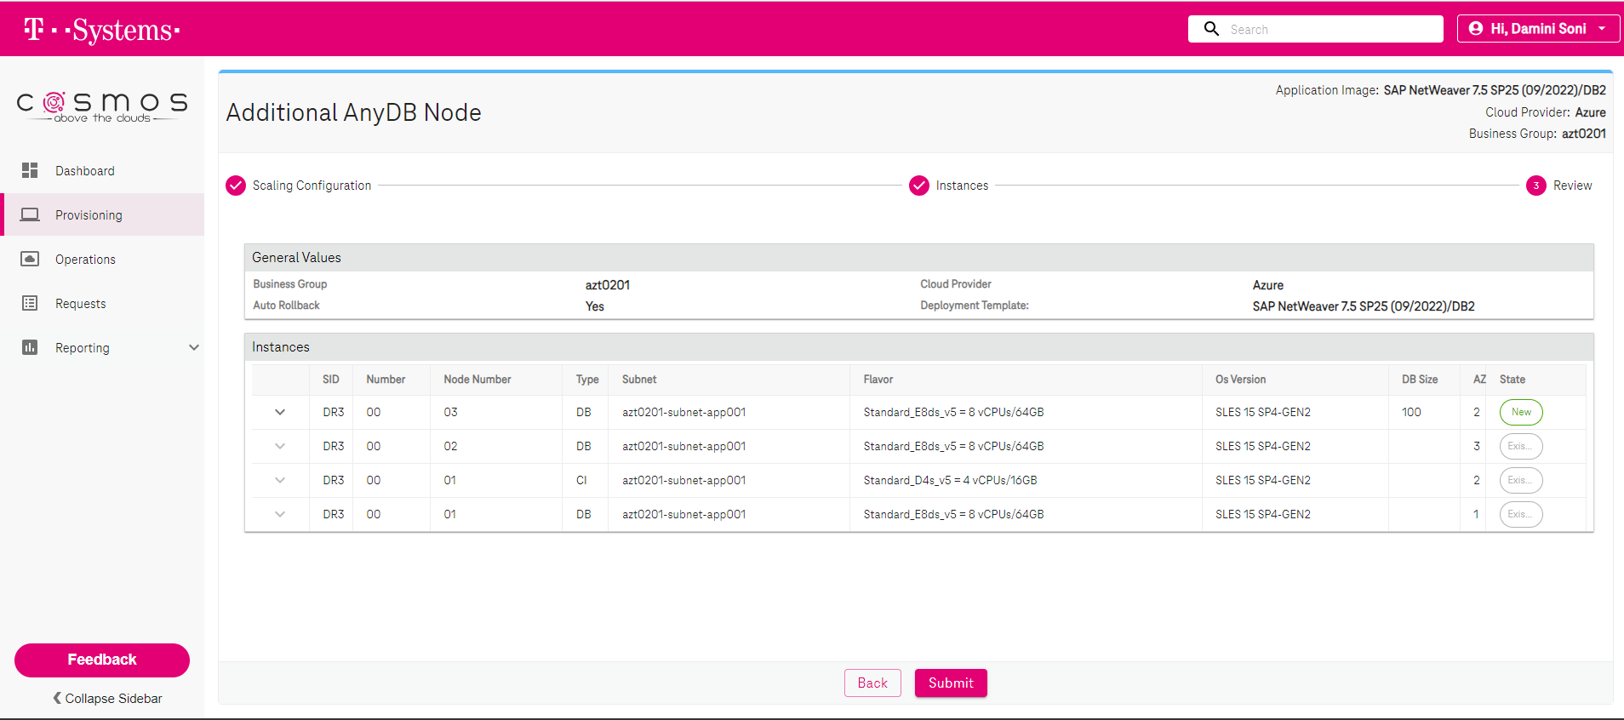

aztdbdr30003:~ # rpm -q pacemaker

pacemaker-2.1.2+20220331.1ad8bbddd-1.1.db2pcmk.x86_64

aztdbdr30003:~ # rpm -q crmsh

crmsh-4.4.0+20220418.cbf7a09e-1.1.db2pcmk.noarch

aztdbdr30003:~ # rpm -q corosync

corosync-3.1.6-db2pcmk.1.x86_64

aztdbdr30003:~ #

aztdbdr30001:~ # cat /etc/hosts | grep -i azt0201.azure.local

192.168.20.75 aztdbdr30001.azt0201.azure.local aztdbdr30001

192.168.20.89 aztdbdr30002.azt0201.azure.local aztdbdr30002

192.168.20.101 aztdbdr30003.azt0201.azure.local aztdbdr30003

192.168.20.124 aztlbdb2dr3.azt0201.azure.local aztlbdb2dr3

aztdbdr30002:~ # cat /etc/hosts | grep -i azt0201.azure.local

192.168.20.89 aztdbdr30002.azt0201.azure.local aztdbdr30002

192.168.20.75 aztdbdr30001.azt0201.azure.local aztdbdr30001

192.168.20.101 aztdbdr30003.azt0201.azure.local aztdbdr30003

192.168.20.124 aztlbdb2dr3.azt0201.azure.local aztlbdb2dr3

aztdbdr30003:~ # cat /etc/hosts | grep -i azt0201.azure.local

192.168.20.89 aztdbdr30002.azt0201.azure.local aztdbdr30002

192.168.20.75 aztdbdr30001.azt0201.azure.local aztdbdr30001

192.168.20.101 aztdbdr30003.azt0201.azure.local aztdbdr30003

192.168.20.91 aztdbdr30002.azt0201.azure.local aztdbdr30002

192.168.20.76 aztdbdr30001.azt0201.azure.local aztdbdr30001

aztdbdr30001:~ # grep -e AllowGroups -e PermitRoot -e Pubkey /etc/ssh/sshd_config

PermitRootLogin yes

PubkeyAuthentication yes

# the setting of "PermitRootLogin without-password".

AllowGroups sapsys users linux sapinst

aztdbdr30002:~ # grep -e AllowGroups -e PermitRoot -e Pubkey /etc/ssh/sshd_config

PermitRootLogin yes

PubkeyAuthentication yes

# the setting of "PermitRootLogin without-password".

AllowGroups sapsys users linux sapinst

aztdbdr30003:~ # grep -e AllowGroups -e PermitRoot -e Pubkey /etc/ssh/sshd_config

PermitRootLogin yes

PubkeyAuthentication yes

# the setting of "PermitRootLogin without-password".

AllowGroups sapsys users linux sapinst

NOTE: After making changes to sshd make sure to reload the changes (systemctl reload sshd)

### Exchange ssh keys for user root

* Check root's home directory : **ls -l ~/.ssh**
* If we don't find files **id_rsa** and **id_rsa.pub**, we need to create a new key pair : **ssh-keygen -b 4096 -t rsa**. Just hit **<enter>** when asked for a password.
* Put the content of **~/.ssh/id_rsa.pub** fromaztdbdr30001 into**~/.ssh/authorized_keys**of aztdbdr30002 and aztdbdr40002 . Do the same for aztdbdr30002 key into aztdbdr30001 and aztdbdr40002.
* Check if access works from each server : **ssh -o StrictHostKeyChecking=no***<server>***hostname.**Be sure, that the access works without password. Otherwise the cluster configuration step below will prompt for the root password.

aztdbdr30001:~ # su - root

aztdbdr30001:~ # db2cm -list

Cluster Status

There is no cluster on this host.

aztdbdr30001:~ # crm status

Could not connect to pacemakerd: Connection refused

crm_mon: Connection to cluster failed: Connection refused

ERROR: status: crm_mon (rc=102):

aztdbdr30001:~ #

1. The following example shows the command syntax and output for creating the Pacemaker cluster and the public network resources, where aztdbdr30001 and aztdbdr30002 are the host names of the nodes in your cluster, azt0201.azure.local is the domain name and eth0 is the network interface (device) name of each host :

aztdbdr30001:~ # db2cm -create -cluster -domain azt0201.azure.local -host aztdbdr30001 -publicEthernet eth0 -host aztdbdr30002 -publicEthernet eth0

Created db2_aztdbdr30001_eth0 resource.

Created db2_aztdbdr30002_eth0 resource.

Cluster created successfully.

aztdbdr30001:~ # crm status

Cluster Summary:

* Stack: corosync

* Current DC: aztdbdr30001 (version 2.1.2+20220331.1ad8bbddd-1.1.db2pcmk-2.1.2+20220331.1ad8bbddd) - partition with quorum

* Last updated: Mon Aug 14 19:19:21 2023

* Last change: Mon Aug 14 19:19:01 2023 by hacluster via crmd on aztdbdr30001

* 2 nodes configured

* 2 resource instances configured

Node List:

* Online: [ aztdbdr30001 aztdbdr30002 ]

Full List of Resources:

* db2_aztdbdr30001_eth0 (ocf::heartbeat:db2ethmon): Started aztdbdr30001

* db2_aztdbdr30002_eth0 (ocf::heartbeat:db2ethmon): Started aztdbdr30002

aztdbdr30001:~ # db2cm -list

Cluster Status

Domain information:

HA configuration = Not configured

Domain name = azt0201.azure.local

Pacemaker version = 2.1.2+20220331.1ad8bbddd-1.1.db2pcmk

Corosync version = 3.1.6

Current domain leader = aztdbdr30001

Number of nodes = 2

Number of resources = 2

Node information:

Name name State

---------------- --------

aztdbdr30001 Online

aztdbdr30002 Online

Resource Information:

Resource Name = db2_aztdbdr30001_eth0

State = Online

Managed = true

Resource Type = Network Interface

Node = aztdbdr30001

Interface Name = eth0

Resource Name = db2_aztdbdr30002_eth0

State = Online

Managed = true

Resource Type = Network Interface

Node = aztdbdr30002

Interface Name = eth0

Fencing Information:

Not configured

Quorum Information:

Two-node quorum

1. The following example shows the command syntax and output for creating the instance cluster domain for the Db2 instance db2dr3:

aztdbdr30001:~ # db2cm -create -instance db2dr3 -host aztdbdr30001

Created db2_aztdbdr30001_db2dr3_0 resource.

Instance resource for db2dr3 on aztdbdr30001 created successfully.

aztdbdr30001:~ # db2cm -create -instance db2dr3 -host aztdbdr30002

Created db2_aztdbdr30002_db2dr3_0 resource.

Instance resource for db2dr3 on aztdbdr30002 created successfully.

1. The following example shows sample output from running crm status to verify the cluster before creating the Db2 databases, HADR resources, and VIP resources

aztdbdr30001:~ # crm status

Cluster Summary:

* Stack: corosync

* Current DC: aztdbdr30001 (version 2.1.2+20220331.1ad8bbddd-1.1.db2pcmk-2.1.2+20220331.1ad8bbddd) - partition with quorum

* Last updated: Mon Aug 14 19:21:43 2023

* Last change: Mon Aug 14 19:21:20 2023 by root via crm_attribute on aztdbdr30001

* 2 nodes configured

* 4 resource instances configured

Node List:

* Online: [ aztdbdr30001 aztdbdr30002 ]

Full List of Resources:

* db2_aztdbdr30001_eth0 (ocf::heartbeat:db2ethmon): Started aztdbdr30001

* db2_aztdbdr30002_eth0 (ocf::heartbeat:db2ethmon): Started aztdbdr30002

* db2_aztdbdr30001_db2dr3_0 (ocf::heartbeat:db2inst): Started aztdbdr30001

* db2_aztdbdr30002_db2dr3_0 (ocf::heartbeat:db2inst): Started aztdbdr30002

aztdbdr30001:~ # db2cm -list

Cluster Status

Domain information:

HA configuration = HADR

Domain name = azt0201.azure.local

Pacemaker version = 2.1.2+20220331.1ad8bbddd-1.1.db2pcmk

Corosync version = 3.1.6

Current domain leader = aztdbdr30001

Number of nodes = 2

Number of resources = 4

Node information:

Name name State

---------------- --------

aztdbdr30001 Online

aztdbdr30002 Online

Resource Information:

Resource Name = db2_aztdbdr30001_db2dr3_0

State = Online

Managed = true

Resource Type = Instance

Node = aztdbdr30001

Instance Name = db2dr3

Resource Name = db2_aztdbdr30001_eth0

State = Online

Managed = true

Resource Type = Network Interface

Node = aztdbdr30001

Interface Name = eth0

Resource Name = db2_aztdbdr30002_db2dr3_0

State = Online

Managed = true

Resource Type = Instance

Node = aztdbdr30002

Instance Name = db2dr3

Resource Name = db2_aztdbdr30002_eth0

State = Online

Managed = true

Resource Type = Network Interface

Node = aztdbdr30002

Interface Name = eth0

Fencing Information:

Not configured

Quorum Information:

Two-node quorum

1. The following example shows the command syntax for creating the HADR resources on a database named SAMPLE on the Db2 instance db2inst1

aztdbdr30001:~ # db2cm -create -db dr3 -instance db2dr3

Database resource for DR3 created successfully.

aztdbdr30001:~ # crm status

Cluster Summary:

* Stack: corosync

* Current DC: aztdbdr30001 (version 2.1.2+20220331.1ad8bbddd-1.1.db2pcmk-2.1.2+20220331.1ad8bbddd) - partition with quorum

* Last updated: Mon Aug 14 19:23:46 2023

* Last change: Mon Aug 14 19:23:05 2023 by root via cibadmin on aztdbdr30001

* 2 nodes configured

* 6 resource instances configured

Node List:

* Online: [ aztdbdr30001 aztdbdr30002 ]

Full List of Resources:

* db2_aztdbdr30001_eth0 (ocf::heartbeat:db2ethmon): Started aztdbdr30001

* db2_aztdbdr30002_eth0 (ocf::heartbeat:db2ethmon): Started aztdbdr30002

* db2_aztdbdr30001_db2dr3_0 (ocf::heartbeat:db2inst): Started aztdbdr30001

* db2_aztdbdr30002_db2dr3_0 (ocf::heartbeat:db2inst): Started aztdbdr30002

* Clone Set: db2_db2dr3_db2dr3_DR3-clone [db2_db2dr3_db2dr3_DR3] (promotable):

* Masters: [ aztdbdr30001 ]

* Slaves: [ aztdbdr30002 ]

aztdbdr30001:~ # db2cm -list

Cluster Status

Domain information:

HA configuration = HADR

Domain name = azt0201.azure.local

Pacemaker version = 2.1.2+20220331.1ad8bbddd-1.1.db2pcmk

Corosync version = 3.1.6

Current domain leader = aztdbdr30001

Number of nodes = 2

Number of resources = 6

Node information:

Name name State

---------------- --------

aztdbdr30001 Online

aztdbdr30002 Online

Resource Information:

Resource Name = db2_aztdbdr30001_db2dr3_0

State = Online

Managed = true

Resource Type = Instance

Node = aztdbdr30001

Instance Name = db2dr3

Resource Name = db2_aztdbdr30001_eth0

State = Online

Managed = true

Resource Type = Network Interface

Node = aztdbdr30001

Interface Name = eth0

Resource Name = db2_aztdbdr30002_db2dr3_0

State = Online

Managed = true

Resource Type = Instance

Node = aztdbdr30002

Instance Name = db2dr3

Resource Name = db2_aztdbdr30002_eth0

State = Online

Managed = true

Resource Type = Network Interface

Node = aztdbdr30002

Interface Name = eth0

Resource Name = db2_db2dr3_db2dr3_DR3

Resource Type = HADR

DB Name = DR3

Managed = true

HADR Primary Instance = db2dr3

HADR Primary Node = aztdbdr30001

HADR Primary State = Online

HADR Standby Instance = db2dr3

HADR Standby Node = aztdbdr30002

HADR Standby State = Online

Fencing Information:

Not configured

Quorum Information:

Two-node quorum

1. The following example shows the command syntax for creating the VIP resource on a database named SAMPLE on the Db2 instance db2inst1

aztdbdr30001:~ # db2cm -create -primaryVIP 192.168.20.124 -db dr3 -instance db2dr3

Primary VIP resource created successfully.

aztdbdr30001:~ # crm status

Cluster Summary:

* Stack: corosync

* Current DC: aztdbdr30001 (version 2.1.2+20220331.1ad8bbddd-1.1.db2pcmk-2.1.2+20220331.1ad8bbddd) - partition with quorum

* Last updated: Mon Aug 14 19:25:56 2023

* Last change: Mon Aug 14 19:25:23 2023 by root via cibadmin on aztdbdr30001

* 2 nodes configured

* 7 resource instances configured

Node List:

* Online: [ aztdbdr30001 aztdbdr30002 ]

Full List of Resources:

* db2_aztdbdr30001_eth0 (ocf::heartbeat:db2ethmon): Started aztdbdr30001

* db2_aztdbdr30002_eth0 (ocf::heartbeat:db2ethmon): Started aztdbdr30002

* db2_aztdbdr30001_db2dr3_0 (ocf::heartbeat:db2inst): Started aztdbdr30001

* db2_aztdbdr30002_db2dr3_0 (ocf::heartbeat:db2inst): Started aztdbdr30002

* Clone Set: db2_db2dr3_db2dr3_DR3-clone [db2_db2dr3_db2dr3_DR3] (promotable):

* Masters: [ aztdbdr30001 ]

* Slaves: [ aztdbdr30002 ]

* db2_db2dr3_db2dr3_DR3-primary-VIP (ocf::heartbeat:IPaddr2): Started aztdbdr30001

aztdbdr30001:~ # db2cm -list

Cluster Status

Domain information:

HA configuration = HADR

Domain name = azt0201.azure.local

Pacemaker version = 2.1.2+20220331.1ad8bbddd-1.1.db2pcmk

Corosync version = 3.1.6

Current domain leader = aztdbdr30001

Number of nodes = 2

Number of resources = 7

Node information:

Name name State

---------------- --------

aztdbdr30001 Online

aztdbdr30002 Online

Resource Information:

Resource Name = db2_aztdbdr30001_db2dr3_0

State = Online

Managed = true

Resource Type = Instance

Node = aztdbdr30001

Instance Name = db2dr3

Resource Name = db2_aztdbdr30001_eth0

State = Online

Managed = true

Resource Type = Network Interface

Node = aztdbdr30001

Interface Name = eth0

Resource Name = db2_aztdbdr30002_db2dr3_0

State = Online

Managed = true

Resource Type = Instance

Node = aztdbdr30002

Instance Name = db2dr3

Resource Name = db2_aztdbdr30002_eth0

State = Online

Managed = true

Resource Type = Network Interface

Node = aztdbdr30002

Interface Name = eth0

Resource Name = db2_db2dr3_db2dr3_DR3

Resource Type = HADR

DB Name = DR3

Managed = true

HADR Primary Instance = db2dr3

HADR Primary Node = aztdbdr30001

HADR Primary State = Online

HADR Standby Instance = db2dr3

HADR Standby Node = aztdbdr30002

HADR Standby State = Online

Resource Name = db2_db2dr3_db2dr3_DR3-primary-VIP

State = Online

Managed = true

Resource Type = IP

Node = aztdbdr30001

Ip Address = 192.168.20.99

Location = aztdbdr30001

Fencing Information:

Not configured

Quorum Information:

Two-node quorum

aztdbdr30001:~ #

Standby VIP resource created successfully.

aztdbdr30001:~ # crm status

Cluster Summary:

* Stack: corosync

* Current DC: aztdbdr30002 (version 2.1.2+20220331.1ad8bbddd-1.1.db2pcmk-2.1.2+20220331.1ad8bbddd) - partition with quorum

* Last updated: Thu Aug 17 06:29:38 2023

* Last change: Thu Aug 17 06:25:13 2023 by root via crm_attribute on aztdbdr30001

* 2 nodes configured

* 8 resource instances configured

Node List:

* Online: [ aztdbdr30001 aztdbdr30002 ]

Full List of Resources:

* db2_aztdbdr30001_eth0 (ocf::heartbeat:db2ethmon): Started aztdbdr30001

* db2_aztdbdr30002_eth0 (ocf::heartbeat:db2ethmon): Started aztdbdr30002

* db2_aztdbdr30001_db2dr3_0 (ocf::heartbeat:db2inst): Started aztdbdr30001

* db2_aztdbdr30002_db2dr3_0 (ocf::heartbeat:db2inst): Started aztdbdr30002

* Clone Set: db2_db2dr3_db2dr3_DR3-clone [db2_db2dr3_db2dr3_DR3] (promotable):

* Masters: [ aztdbdr30001 ]

* Slaves: [ aztdbdr30002 ]

* db2_db2dr3_db2dr3_DR3-primary-VIP (ocf::heartbeat:IPaddr2): Started aztdbdr30001

* db2_db2dr3_db2dr3_DR3-standby-VIP (ocf::heartbeat:IPaddr2): Started aztdbdr30002

aztdbdr30001:~ # db2cm -list

Cluster Status

Domain information:

HA configuration = HADR

Domain name = azt0201.azure.local

Pacemaker version = 2.1.2+20220331.1ad8bbddd-1.1.db2pcmk

Corosync version = 3.1.6

Current domain leader = aztdbdr30002

Number of nodes = 2

Number of resources = 8

Node information:

Name name State

---------------- --------

aztdbdr30001 Online

aztdbdr30002 Online

Resource Information:

Resource Name = db2_aztdbdr30001_db2dr3_0

State = Online

Managed = true

Resource Type = Instance

Node = aztdbdr30001

Instance Name = db2dr3

Resource Name = db2_aztdbdr30001_eth0

State = Online

Managed = true

Resource Type = Network Interface

Node = aztdbdr30001

Interface Name = eth0

Resource Name = db2_aztdbdr30002_db2dr3_0

State = Online

Managed = true

Resource Type = Instance

Node = aztdbdr30002

Instance Name = db2dr3

Resource Name = db2_aztdbdr30002_eth0

State = Online

Managed = true

Resource Type = Network Interface

Node = aztdbdr30002

Interface Name = eth0

Resource Name = db2_db2dr3_db2dr3_DR3

Resource Type = HADR

DB Name = DR3

Managed = true

HADR Primary Instance = db2dr3

HADR Primary Node = aztdbdr30001

HADR Primary State = Online

HADR Standby Instance = db2dr3

HADR Standby Node = aztdbdr30002

HADR Standby State = Online

Resource Name = db2_db2dr3_db2dr3_DR3-primary-VIP

State = Online

Managed = true

Resource Type = IP

Node = aztdbdr30001

Ip Address = 192.168.20.99

Location = aztdbdr30001

Resource Name = db2_db2dr3_db2dr3_DR3-standby-VIP

State = Online

Managed = true

Resource Type = IP

Node = aztdbdr30001

Ip Address = 192.168.20.90

Location = aztdbdr30002

Fencing Information:

Not configured

Quorum Information:

Two-node quorum

db2dr3> db2pd -d dr3 -hadr

Database Member 0 -- Database DR3 -- Active -- Up 0 days 00:03:41 -- Date 2023-08-17-06.28.51.921435

HADR_ROLE = PRIMARY

REPLAY_TYPE = PHYSICAL

HADR_SYNCMODE = NEARSYNC

STANDBY_ID = 1

LOG_STREAM_ID = 0

HADR_STATE = PEER

HADR_FLAGS = TCP_PROTOCOL

PRIMARY_MEMBER_HOST = aztdbdr30001.azt0201.azure.local

PRIMARY_INSTANCE = db2dr3

PRIMARY_MEMBER = 0

STANDBY_MEMBER_HOST = aztdbdr30002.azt0201.azure.local

STANDBY_INSTANCE = db2dr3

STANDBY_MEMBER = 0

HADR_CONNECT_STATUS = CONNECTED

HADR_CONNECT_STATUS_TIME = 08/17/2023 06:25:13.439927 (1692253513)

HEARTBEAT_INTERVAL(seconds) = 5

HEARTBEAT_MISSED = 0

HEARTBEAT_EXPECTED = 43

HADR_TIMEOUT(seconds) = 120

TIME_SINCE_LAST_RECV(seconds) = 2

PEER_WAIT_LIMIT(seconds) = 0

LOG_HADR_WAIT_CUR(seconds) = 0.000

LOG_HADR_WAIT_RECENT_AVG(seconds) = 0.000001

LOG_HADR_WAIT_ACCUMULATED(seconds) = 0.000

LOG_HADR_WAIT_COUNT = 3

SOCK_SEND_BUF_REQUESTED,ACTUAL(bytes) = 0, 16384

SOCK_RECV_BUF_REQUESTED,ACTUAL(bytes) = 0, 131072

PRIMARY_LOG_FILE,PAGE,POS = S0000019.LOG, 0, 39174438838

STANDBY_LOG_FILE,PAGE,POS = S0000019.LOG, 0, 39174438838

HADR_LOG_GAP(bytes) = 0

STANDBY_REPLAY_LOG_FILE,PAGE,POS = S0000019.LOG, 0, 39174438838

STANDBY_RECV_REPLAY_GAP(bytes) = 0

PRIMARY_LOG_TIME = 08/17/2023 06:28:47.000000 (1692253727)

STANDBY_LOG_TIME = 08/17/2023 06:28:47.000000 (1692253727)

STANDBY_REPLAY_LOG_TIME = 08/17/2023 06:28:47.000000 (1692253727)

STANDBY_RECV_BUF_SIZE(pages) = 2048

STANDBY_RECV_BUF_PERCENT = 0

STANDBY_SPOOL_LIMIT(pages) = 1000

STANDBY_SPOOL_PERCENT = 0

STANDBY_ERROR_TIME = NULL

PEER_WINDOW(seconds) = 240

PEER_WINDOW_END = 08/17/2023 06:32:48.000000 (1692253968)

READS_ON_STANDBY_ENABLED = N

HADR_LAST_TAKEOVER_TIME = 08/17/2023 06:28:39.000000 (1692253719)

aztdbdr30001:~ # ps -ef | grep db2sysc

db2dr3 7360 7358 1 06:13 ? 00:00:16 db2sysc 0

root 23050 11848 0 06:30 pts/0 00:00:00 grep --color=auto db2sysc

aztdbdr30001:~ # kill -9 7360

aztdbdr30001:~ # db2cm -list

Cluster Status

Domain information:

HA configuration = HADR

Domain name = azt0201.azure.local

Pacemaker version = 2.1.2+20220331.1ad8bbddd-1.1.db2pcmk

Corosync version = 3.1.6

Current domain leader = aztdbdr30002

Number of nodes = 2

Number of resources = 8

Node information:

Name name State

---------------- --------

aztdbdr30001 Online

aztdbdr30002 Online

Resource Information:

Resource Name = db2_aztdbdr30001_db2dr3_0

State = Online

Managed = true

Resource Type = Instance

Node = aztdbdr30001

Instance Name = db2dr3

Resource Name = db2_aztdbdr30001_eth0

State = Online

Managed = true

Resource Type = Network Interface

Node = aztdbdr30001

Interface Name = eth0

Resource Name = db2_aztdbdr30002_db2dr3_0

State = Online

Managed = true

Resource Type = Instance

Node = aztdbdr30002

Instance Name = db2dr3

Resource Name = db2_aztdbdr30002_eth0

State = Online

Managed = true

Resource Type = Network Interface

Node = aztdbdr30002

Interface Name = eth0

Resource Name = db2_db2dr3_db2dr3_DR3

Resource Type = HADR

DB Name = DR3

Managed = true

HADR Primary Instance = db2dr3

HADR Primary Node = aztdbdr30002

HADR Primary State = Online

HADR Standby Instance =

HADR Standby Node =

HADR Standby State = Offline

Resource Name = db2_db2dr3_db2dr3_DR3-primary-VIP

State = Online

Managed = true

Resource Type = IP

Node = aztdbdr30001

Ip Address = 192.168.20.99

Location = aztdbdr30002

Resource Name = db2_db2dr3_db2dr3_DR3-standby-VIP

State = Offline

Managed = true

Resource Type = IP

Node = aztdbdr30001

Ip Address = 192.168.20.90

Location = resource db2_db2dr3_db2dr3_DR3-standby-VIP is NOT running

Fencing Information:

Not configured

Quorum Information:

Two-node quorum

aztdbdr30001:~ # crm status

Cluster Summary:

* Stack: corosync

* Current DC: aztdbdr30002 (version 2.1.2+20220331.1ad8bbddd-1.1.db2pcmk-2.1.2+20220331.1ad8bbddd) - partition with quorum

* Last updated: Thu Aug 17 06:31:47 2023

* Last change: Thu Aug 17 06:31:27 2023 by root via crm_attribute on aztdbdr30001

* 2 nodes configured

* 8 resource instances configured

Node List:

* Online: [ aztdbdr30001 aztdbdr30002 ]

Full List of Resources:

* db2_aztdbdr30001_eth0 (ocf::heartbeat:db2ethmon): Started aztdbdr30001

* db2_aztdbdr30002_eth0 (ocf::heartbeat:db2ethmon): Started aztdbdr30002

* db2_aztdbdr30001_db2dr3_0 (ocf::heartbeat:db2inst): Started aztdbdr30001

* db2_aztdbdr30002_db2dr3_0 (ocf::heartbeat:db2inst): Started aztdbdr30002

* Clone Set: db2_db2dr3_db2dr3_DR3-clone [db2_db2dr3_db2dr3_DR3] (promotable):

* Masters: [ aztdbdr30002 ]

* Slaves: [ aztdbdr30001 ]

* db2_db2dr3_db2dr3_DR3-primary-VIP (ocf::heartbeat:IPaddr2): Started aztdbdr30002

* db2_db2dr3_db2dr3_DR3-standby-VIP (ocf::heartbeat:IPaddr2): Started aztdbdr30001

Failed Resource Actions:

* db2_aztdbdr30001_db2dr3_0_monitor_10000 on aztdbdr30001 'not running' (7): call=22, status='complete', last-rc-change='Thu Aug 17 06:31:18 2023', queued=0

ms, exec=0ms

aztdbdr30001:~ # crm status

Cluster Summary:

* Stack: corosync

* Current DC: aztdbdr30002 (version 2.1.2+20220331.1ad8bbddd-1.1.db2pcmk-2.1.2+20220331.1ad8bbddd) - partition with quorum

* Last updated: Thu Aug 17 06:51:57 2023

* Last change: Thu Aug 17 06:31:27 2023 by root via crm_attribute on aztdbdr30001

* 2 nodes configured

* 8 resource instances configured

Node List:

* Online: [ aztdbdr30001 aztdbdr30002 ]

Full List of Resources:

* db2_aztdbdr30001_eth0 (ocf::heartbeat:db2ethmon): Started aztdbdr30001

* db2_aztdbdr30002_eth0 (ocf::heartbeat:db2ethmon): Started aztdbdr30002

* db2_aztdbdr30001_db2dr3_0 (ocf::heartbeat:db2inst): Started aztdbdr30001

* db2_aztdbdr30002_db2dr3_0 (ocf::heartbeat:db2inst): Started aztdbdr30002

* Clone Set: db2_db2dr3_db2dr3_DR3-clone [db2_db2dr3_db2dr3_DR3] (promotable):

* Masters: [ aztdbdr30002 ]

* Slaves: [ aztdbdr30001 ]

* db2_db2dr3_db2dr3_DR3-primary-VIP (ocf::heartbeat:IPaddr2): Started aztdbdr30002

* db2_db2dr3_db2dr3_DR3-standby-VIP (ocf::heartbeat:IPaddr2): Started aztdbdr30001

aztdbdr30003:/etc/zypp/repos.d # systemctl status firewalld

● firewalld.service - firewalld - dynamic firewall daemon

Loaded: loaded (/usr/lib/systemd/system/firewalld.service; disabled; vendor preset: disabled)

Active: active (running) since Thu 2023-08-17 09:44:18 UTC; 2s ago

Docs: man:firewalld(1)

Main PID: 26794 (firewalld)

Tasks: 2

CGroup: /system.slice/firewalld.service

└─ 26794 /usr/bin/python3 /usr/sbin/firewalld --nofork --nopid

Aug 17 09:44:17 aztdbdr30003 systemd[1]: Starting firewalld - dynamic firewall daemon...

Aug 17 09:44:18 aztdbdr30003 systemd[1]: Started firewalld - dynamic firewall daemon.

aztdbdr30003:/etc/zypp/repos.d # systemctl enable firewalld

Created symlink /etc/systemd/system/dbus-org.fedoraproject.FirewallD1.service → /usr/lib/systemd/system/firewalld.service.

Created symlink /etc/systemd/system/multi-user.target.wants/firewalld.service → /usr/lib/systemd/system/firewalld.service.

aztdbdr30003:/etc/zypp/repos.d # systemctl status firewalld

● firewalld.service - firewalld - dynamic firewall daemon

Loaded: loaded (/usr/lib/systemd/system/firewalld.service; enabled; vendor preset: disabled)

Active: active (running) since Thu 2023-08-17 09:44:18 UTC; 1min 12s ago

Docs: man:firewalld(1)

Main PID: 26794 (firewalld)

Tasks: 2

CGroup: /system.slice/firewalld.service

└─ 26794 /usr/bin/python3 /usr/sbin/firewalld --nofork --nopid

Aug 17 09:44:17 aztdbdr30003 systemd[1]: Starting firewalld - dynamic firewall daemon...

Aug 17 09:44:18 aztdbdr30003 systemd[1]: Started firewalld - dynamic firewall daemon.

aztdbdr30003:/etc/zypp/repos.d # firewall-cmd --zone=public --add-port=3121/tcp --permanent

success

aztdbdr30003:/etc/zypp/repos.d # firewall-cmd --zone=public --add-port=5403/tcp --permanent

success

aztdbdr30003:/etc/zypp/repos.d # firewall-cmd --zone=public --add-port=5404/tcp --permanent

success

aztdbdr30003:/etc/zypp/repos.d # firewall-cmd --zone=public --add-port=5405/tcp --permanent

success

aztdbdr30003:/etc/zypp/repos.d #

aztdbdr30001:/tmp # db2cm -create -qdevice aztdbdr30003

Successfully configured qdevice on nodes aztdbdr30001 and aztdbdr30002

Attempting to start qdevice on aztdbdr30003

Quorum device aztdbdr30003 added successfully.

